Date: 31 Jan, 2014 M.S. Raghavendra Sriram

1000854840

EE 5322 Intelligent Control Systems

Assignment no 1

Stock Market Time Series Analysis and DFT

The closing price for the NASDAQ tracking stock NVDA is given as an Excel file. Note there are 254 trading days in the year. There are about 22 trading days in a month. Therefore, for trading on a monthly time scale, one considers a 20-day time window. This allows one to capture many motions of the stock while not spending too much in broker’s fees by churning the stock. On-line trades now run about $15 per transaction.

1. a. Compute the 20 day MA. Plot on the same figure as the stock closing price.

b. Plot the stock minus the 20 day MA.

c. Compute and plot the 20 day moving sample variance.

d. On the same figure, plot the stock closing price, the 20 day MA, and

the MA plus three times the 20 day standard deviation

the MA minus three times the 20 day standard deviation.

The last two lines are known as the Bollinger Bands, after John Bollinger.

Solution :

%%

% Import data into matlab.

stock_prices = b; % import data from excell and save it in an array.

data = size(b); % save the size of the data array.

data = data(1); % select data from column 1.

%%

%compute and plot the moving average

sum = 0; % initiate sum = 0.

mov_avg = size(stock_prices); % set range of moving average.

for i = 1:data % setting up loop to calculate the sum.

sum = sum + stock_prices(i); % calculating the sum with each stock price iteratively.

if i <= win_size % check if the value of i is less than the window size.

mov_avg(i) = sum/i; % calculate the moving average.

else

sum = sum - stock_prices(i-win_size);% sum is the diff of final sum and stock prices* window moving backwards.

mov_avg(i) = sum/win_size; % moving average of particular iteration is sum/window.

end

end

%%

%plot the stock minus the 20 day moving average

figure(1);

plot(stock_prices);

title('1-A: stock prices at closing and 20 day moving average');

hold on;

plot(mov_avg); % plot moving average for each iteration.

%plot the stock minus the 20 day moving average

figure(2);

plot(stock_prices-mov_avg'); % plot the difference of the moving average abd the stock prices.

hold on;

title('1-B: stock prices at closing minus 20 day moving average');

%%

%Calculating the moving variance

mov_var = size(stock_prices); % Assign the size of the moving variance matrix.

sum = 0; % Reset sum to 0.

for i = 1:data % Set the number of iterations.

sum = sum+(stock_prices(i)-mov_avg(i))^2;% calculate the sum for the moving variance.

if i <= win_size %if the index is less than the window size, don't subtract old data

mov_var(i) = sum/i; % calculate the moving variance

else

sum = sum-(stock_prices(i-win_size)-mov_avg(i-win_size))^2;% calculate the sum for moving variance.

mov_var(i) = sum / win_size; % calculate the moving variance

end

end

%%

%plot the moving variance

figure(3);

plot(mov_var); % plot the moving variance.

title('1-C: Moving Variance');

%%

%calculate boolinger bands

%[mid,uppr,lowr] = bollinger(stock_prices, 20 , 0, 3);

[mid,uppr,lowr]= bollinger(stock_prices);

Bollinger3 = [mid, uppr,lowr];

%%

%compute the 20 day deviation (deviation) from the variance

deviation=sqrt(mov_var);

%plot the closing price, 20 day mov_avg.

figure(4);

plot(stock_prices); % plot stock prices.

hold on;

plot(mov_avg); % plot the moving average.

hold on;

title('1-D: stock prices at closing , 20 day moving average, and Bollinger Bands');

figure(5);

plot(Bollinger)

hold on;

title('1-D : Bollinger Bands of stock_prices')

Plots :

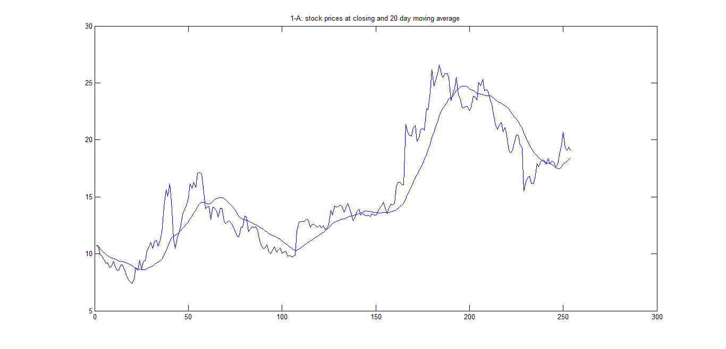

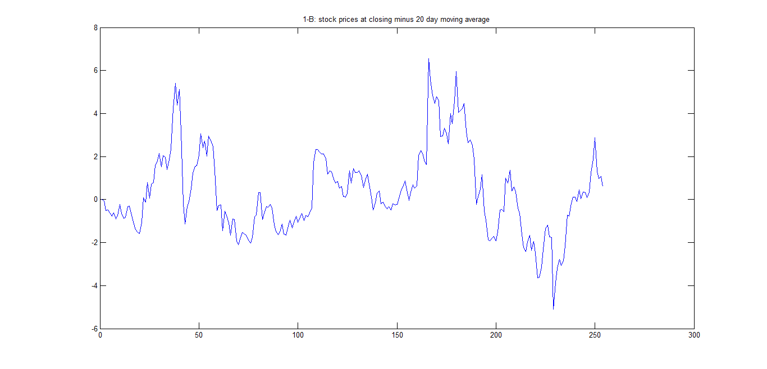

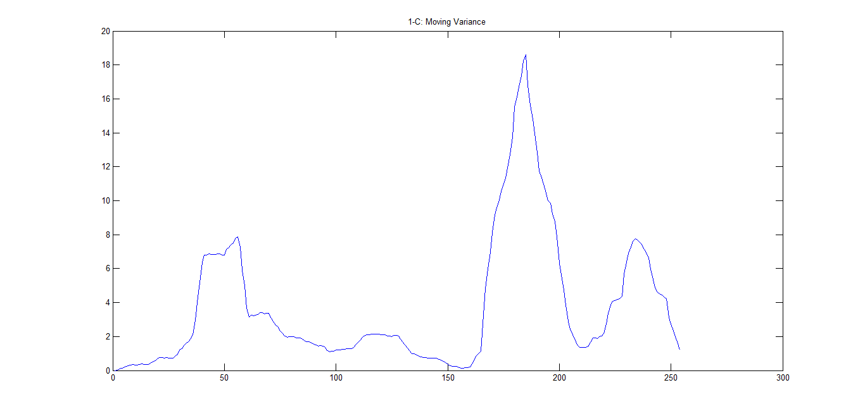

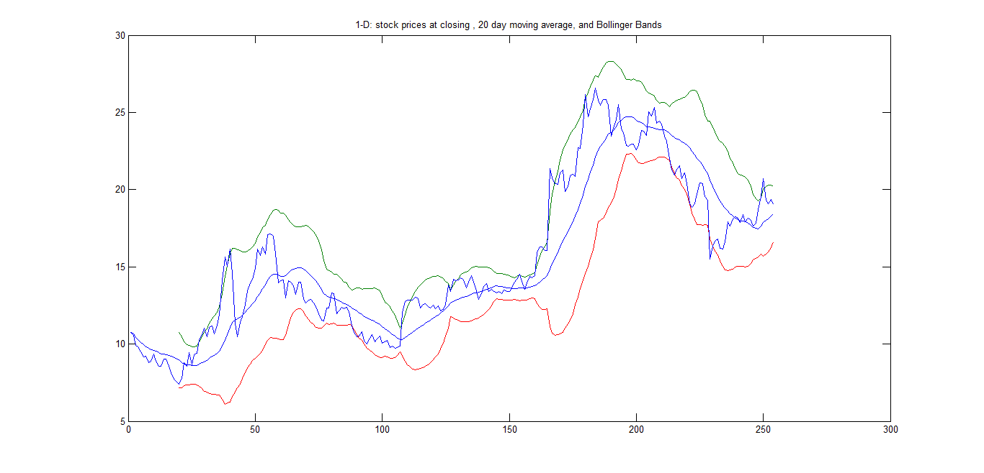

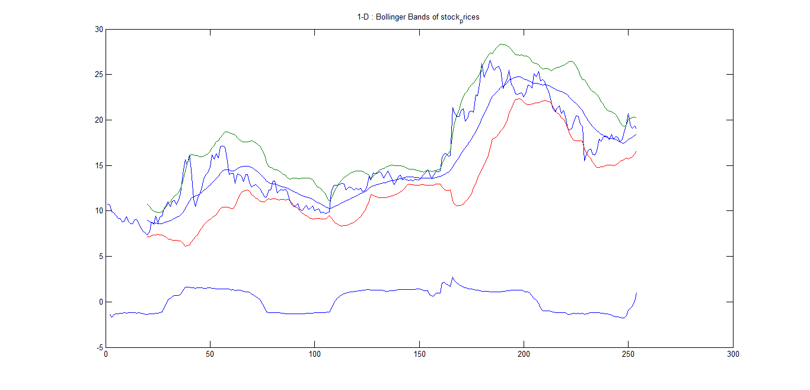

--------------------------------------------------------------------------------------------------------------------------------------------------------------------------------------------------------------------

2. a. Compute and plot the 20 day moving skew.

b. Compute and plot the 20 day moving kurtosis.

c. Can you use these statistics to find a leading indicator for movements in the stock?

i.e. how can we predict using statistics when the stock is about to break its trend (change its pattern)?

**Solution: No it is not possible to predict when the stocks will change their trend.**

%%

%compute and plot the 20 day moving skew

mov_skew = size(stock_prices);

sum = 0;

for i = 1:data

sum = sum+(stock_prices(i)-mov_avg(i))^3;

if i <= win_size %if the index is less than the window size, don't subtract old data

mov_skew(i) = sum/(i*deviation(i)^3);

else

sum = sum-(stock_prices(i-win_size)-mov_avg(i-win_size))^3;

mov_skew(i) = sum/(win_size*deviation(i)^3);

end

end

%%

figure(6);

plot(mov_skew);

title('2-A: 20 day Moving Skew');

%%

%compute the 20 day moving kurtosis

mov_kurt = size(stock_prices);

% k = kurtosis(mov_kurt)

sum = 0;

for i = 1:data

sum = sum+(stock_prices(i)-mov_avg(i))^4;

if i <= win_size % check if the index is less than the window size,

mov_kurt(i) = sum/(i*deviation(i)^4);

else

sum = sum-(stock_prices(i-win_size)-mov_avg(i-win_size))^4;

mov_kurt(i) = sum/(win_size*deviation(i)^4);

end

end

%%

%plot the 20 day moving kurtosis

figure(7);

plot(mov_kurt);

title('2-B: 20 day moving kurtosis');

Plot:

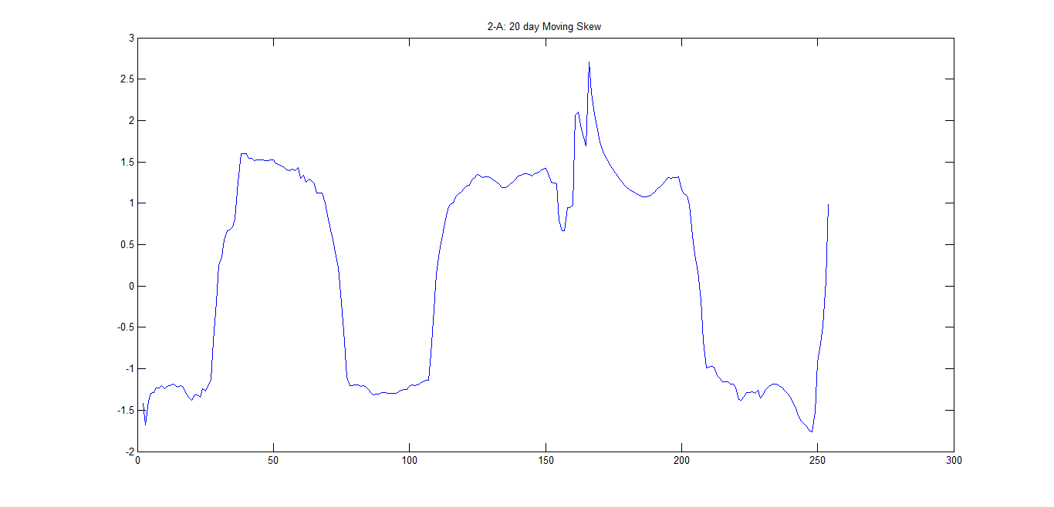

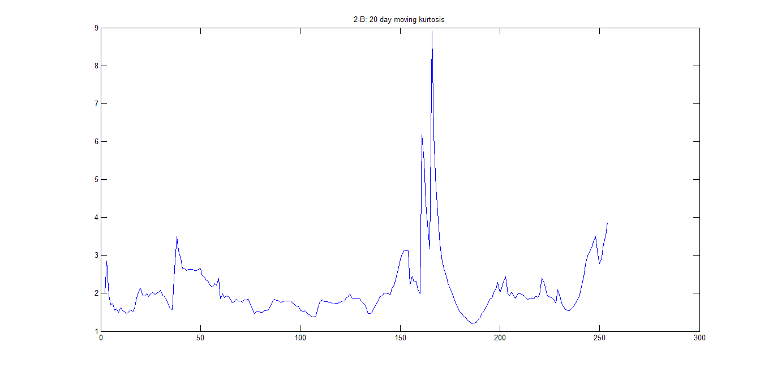

3. a. Compute and plot the autocorrelation.

b. Compute and plot the autocovariance

Solution:

%%

%compute and plot the autocorrelation

auto_cor = size(stock_prices);

for n = 1:data - win_size

sum = 0;

for k = 1:win_size

sum=stock_prices(k)*stock_prices(k+n);

end

auto_cor(n)=sum/win_size;

end

%%

figure(8);

plot(auto_cor);

title('3-A: Autocorrelation');

%%

%compute and plot the autocovariance

auto_cov=size(stock_prices);

for n=1:data - win_size

sum=0;

for k=1:win_size

sum=(stock_prices(k)-mov_avg(k))*(stock_prices(k+n)-mov_avg(k+n));

end

auto_cov(n)=sum/win_size;

end

%%

figure(9);

plot(auto_cov);

title('3-B: Autocovariance');

Plots:

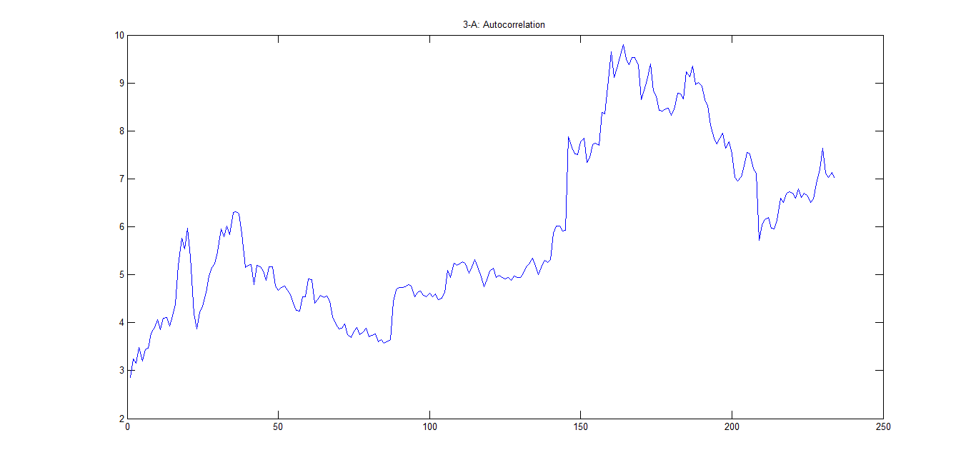

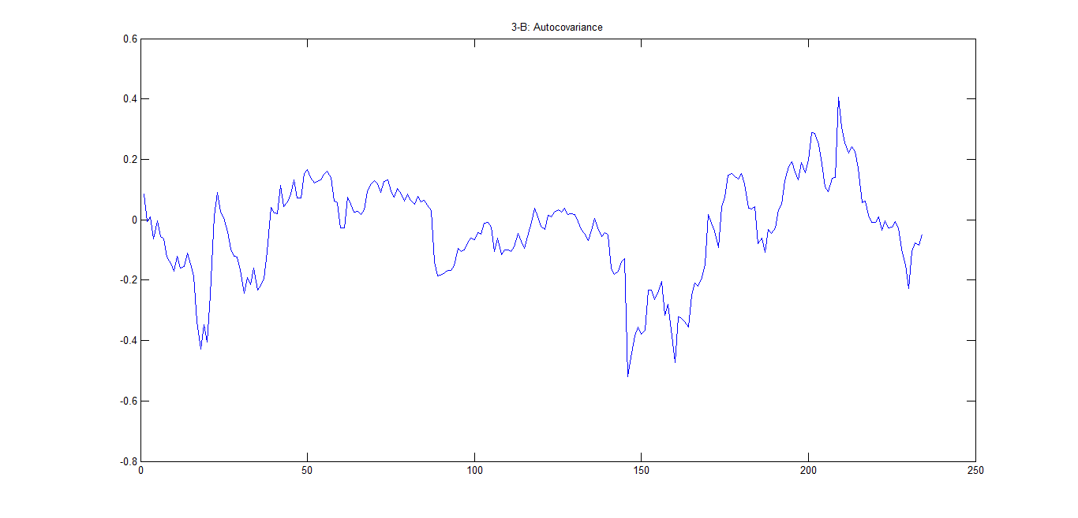

4. a. Compute and plot the DFT of the entire signal.

b. Compute and plot the DFT of the entire signal minus the 20 day MA.

c. Compute and plot the time-varying DFT using a moving window of 20 days.

d. Compute and plot the time-varying DFT using fixed bins of 20 days in length.

Any news about predicting movements in this stock?

**Solution: The stock prices are rising towards the end of the year. It is not a good time to buy.**

%%

%compute and plot the DFT

DFT = fft(stock_prices',data);

%%

figure(10);

k = 1:data;

plot(k,abs(DFT));

axis([0,data,0,100]);

title('4-A: DFT');

%%

%compute and plot the DFT - 20 day moving average

DFT2 = fft(stock_prices',data);

DFT2 = DFT2 - mov_avg;

%%

figure(11);

k = 1:data;

plot(k,abs(DFT2));

axis([0,data,0,100]);

title('4-B: DFT minus 20 day moving average');

%%

%compute and plot the moving window DFT

DFT3 = fft(mov_avg',data);

%%

figure(12);

k = 1:data;

plot(k,abs(DFT3));

axis([0,data,0,100]);

title('4-C: moving window DFT');

%%

L = [1:254];

w = 2*pi*(L-1)/254; % Frequency being scaled to be within 2pi

time = L(:,1);

price = L(:,2);

for k = 1:254

Sum = 0;

if k-win_size+1 < 0

for n = 1:k

Sum = Sum + price(n)*exp(-1i*2*pi*(k-1)*(n-1)/254);

cost(k,n) = Sum;

end

else

for n = 1:254

Sum = Sum + price(n)*exp(-1i*2*pi*(k-1)*(n-1)/254);

cost(k,n) = Sum;

end

end

end

figure(14)

mesh(win_size,time,abs(cost))

hold on;

%%

%compute and plot the fixed bin DFT

DFT4 = [];

for i = 1:data/win_size

DFT4 = [DFT4, fft(stock_prices((i - 1)*win_size+1:i*win_size))];

end

%%

figure(13);

dim = size(DFT4);

k = 1:dim(2);

plot(k,abs(DFT4));

axis([0,data,0,1])

title('4-D: Fixed bin DFT');

Plots:

